CPSC131 - Symbolic Toolbox & MuPad (30 points)

Solve each of the following problems. #3 & 4 - Use comments to explain your steps.

1. (8 pts) Define the following function symbolically: 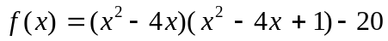

a) Expand f(x)

b) Show that 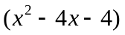is a factor of f using division.

c) Factor f

d) Find the roots of f

e) Substitute one of the roots you found in f to show 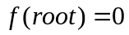

f) Find 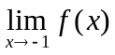

2. (2 pts) Determine the polynomial that has the following roots: 4, -2, 1, 0

3. (2 pts) Solve the following system: 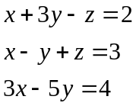

4. (4 pts) Find the values of x where the graph of y = 3 ^{x} – 3x has a horizontal tangent line. For each point found, determine whether the function has a max, min or neither there. Give decimal answers.

5. (5 pts) Ship A is traveling north at 6 mph and ship B is traveling west at 12 mph. When ship A was dead ahead of ship B, it was 6 miles away. Determine the minimum distance between the ships.

6. (4 pts) A ceramic tile has the design show in the figure. The border between the red and white areas has the equation y = A sin(πx/15). Determine the value of A (find the exact and decimal approximation) such that the white area equals the red area.
